# Question

Given a sorted array *nums*, remove the duplicates [**in-place**](https://en.wikipedia.org/wiki/In-place_algorithm) such that each element appears only *once* and returns the new length.

Do not allocate extra space for another array, you must do this by **modifying the input array**[**in-place**](https://en.wikipedia.org/wiki/In-place_algorithm) with O(1) extra memory.

**Clarification:**

Confused why the returned value is an integer but your answer is an array?

Note that the input array is passed in by **reference**, which means a modification to the input array will be known to the caller as well.

Internally you can think of this:

// **nums** is passed in by reference. (i.e., without making a copy)

int len = removeDuplicates(nums);

// any modification to **nums** in your function would be known by the caller.

// using the length returned by your function, it prints the first **len** elements.

for (int i = 0; i < len; i++) {

    print(nums[i]);

}

**Example 1:**

**Input:** nums = [1,1,2]

**Output:** 2, nums = [1,2]

**Explanation:** Your function should return length = **2**, with the first two elements of *nums* being **1** and **2** respectively. It doesn't matter what you leave beyond the returned length.

**Example 2:**

**Input:** nums = [0,0,1,1,1,2,2,3,3,4]

**Output:** 5, nums = [0,1,2,3,4]

**Explanation:** Your function should return length = **5**, with the first five elements of *nums* being modified to **0**, **1**, **2**, **3**, and **4** respectively. It doesn't matter what values are set beyond the returned length.

**Constraints:**

* 0 <= nums.length <= 3 * 104
* -104 <= nums[i] <= 104
* nums is sorted in ascending order.

Hide Hint #1

In this problem, the key point to focus on is the input array being sorted. As far as duplicate elements are concerned, what is their positioning in the array when the given array is sorted? Look at the image above for the answer. If we know the position of one of the elements, do we also know the positioning of all the duplicate elements?  
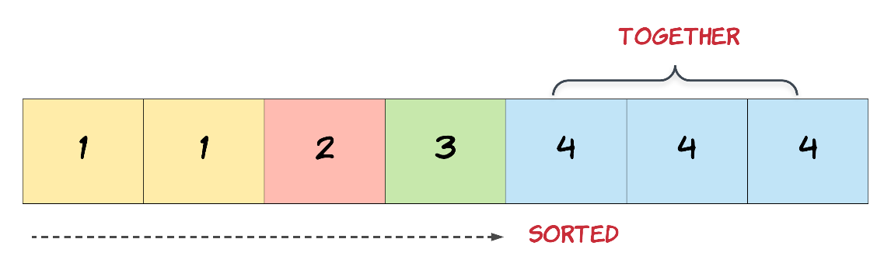

Hide Hint #2

We need to modify the array in-place and the size of the final array would potentially be smaller than the size of the input array. So, we ought to use a two-pointer approach here. One, that would keep track of the current element in the original array and another one for just the unique elements.

Hide Hint #3

Essentially, once an element is encountered, you simply need to **bypass** its duplicates and move on to the next unique element.

# Solution

#### **Approach 1: Two Pointers**

**Algorithm**

Since the array is already sorted, we can keep two pointers i*i* and j*j*, where i*i* is the slow-runner while j*j* is the fast-runner. As long as nums[i] = nums[j]*nums*[*i*]=*nums*[*j*], we increment j*j* to skip the duplicate.

When we encounter nums[j] \neq nums[i]*nums*[*j*]​=*nums*[*i*], the duplicate run has ended so we must copy its value to nums[i + 1]*nums*[*i*+1]. i*i* is then incremented and we repeat the same process again until j*j* reaches the end of array.

|  |
| --- |
| public int removeDuplicates(int[] nums) {  if (nums.length == 0) return 0;  int i = 0;  for (int j = 1; j < nums.length; j++) {  if (nums[j] != nums[i]) {  i++;  nums[i] = nums[j];  }  }  return i + 1;  } |

**Complexity analysis**

* Time complextiy : O(n)*O*(*n*). Assume that n*n* is the length of array. Each of i*i* and j*j* traverses at most n*n* steps.
* Space complexity : O(1)*O*(1).